Driving hydraulic Compact Earth block press with Arduino

See animation on <https://www.youtube.com/watch?v=0-BRCh19b1Q>

This animation only has 2 cylinders, as here the block is only pressed from the bottom, not from the top. Our press is more sophisticated as it also presses from the top, so we have 3 cylinders we have to drive.

**6 I/O ports driving 3 12v solenoids for 3 hydraulic cylinders (push and pull) :**

Bottom up (to press the earthblock from the bottom) 1: extend, 2: retract

Top Down (to press the earthblock from the top) 3: extend, 4: retract

Left-right (to move the top opening part) 5: extend, 6: retract

2 I/O ports driving 12v linear actuator (7-8) and 2 I/O ports driving 24v linear actuator (9-10)

This is a separate system to move a pallet so that the press can push 2 blocks on the pallet, and the pallet then moves over 2.5” so that the next row of 2 blocks can be pushed on. The 24v linear actuator will move the pallet over 2.5”, while the second 12v linear actuator will push the pallet 0.5” out before it moves, and then 0.5” back. If the pallet is full, (pallet pushes Micro-Roller-Lever-Arm at the end) the pressing sequence stops, and the 24v linear actuator pulls all the way back in (pallet pushes Micro-roller at the start).

6 Sensors

1Pressure switch (gives a signal when max pressure is reached, which happens when a cylinder is either fully extended or retracted)

TOF sensor VL53L0X for Bottom up

IR sensor 1 for Top down

IR sensor 2 for Left-right

IR sensors measure the correct position of the top down and left right extensions

Micro-Roller-Lever for pallet system, to indicate when pallet is full.

Micro-roller-lever for pallet system, to indicate starting position for new pallet

Keyboard input and screen output

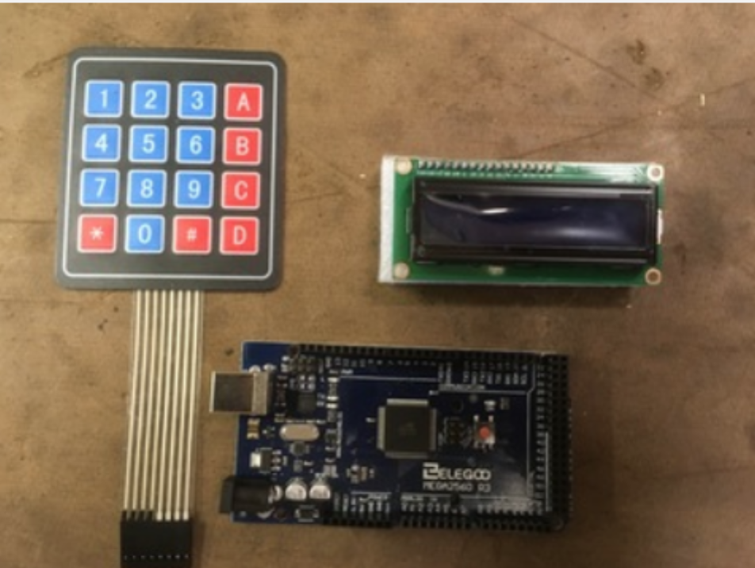

Here is the current layout of our system. (this layout uses an old non i2c display, which we since changed to an i2c)

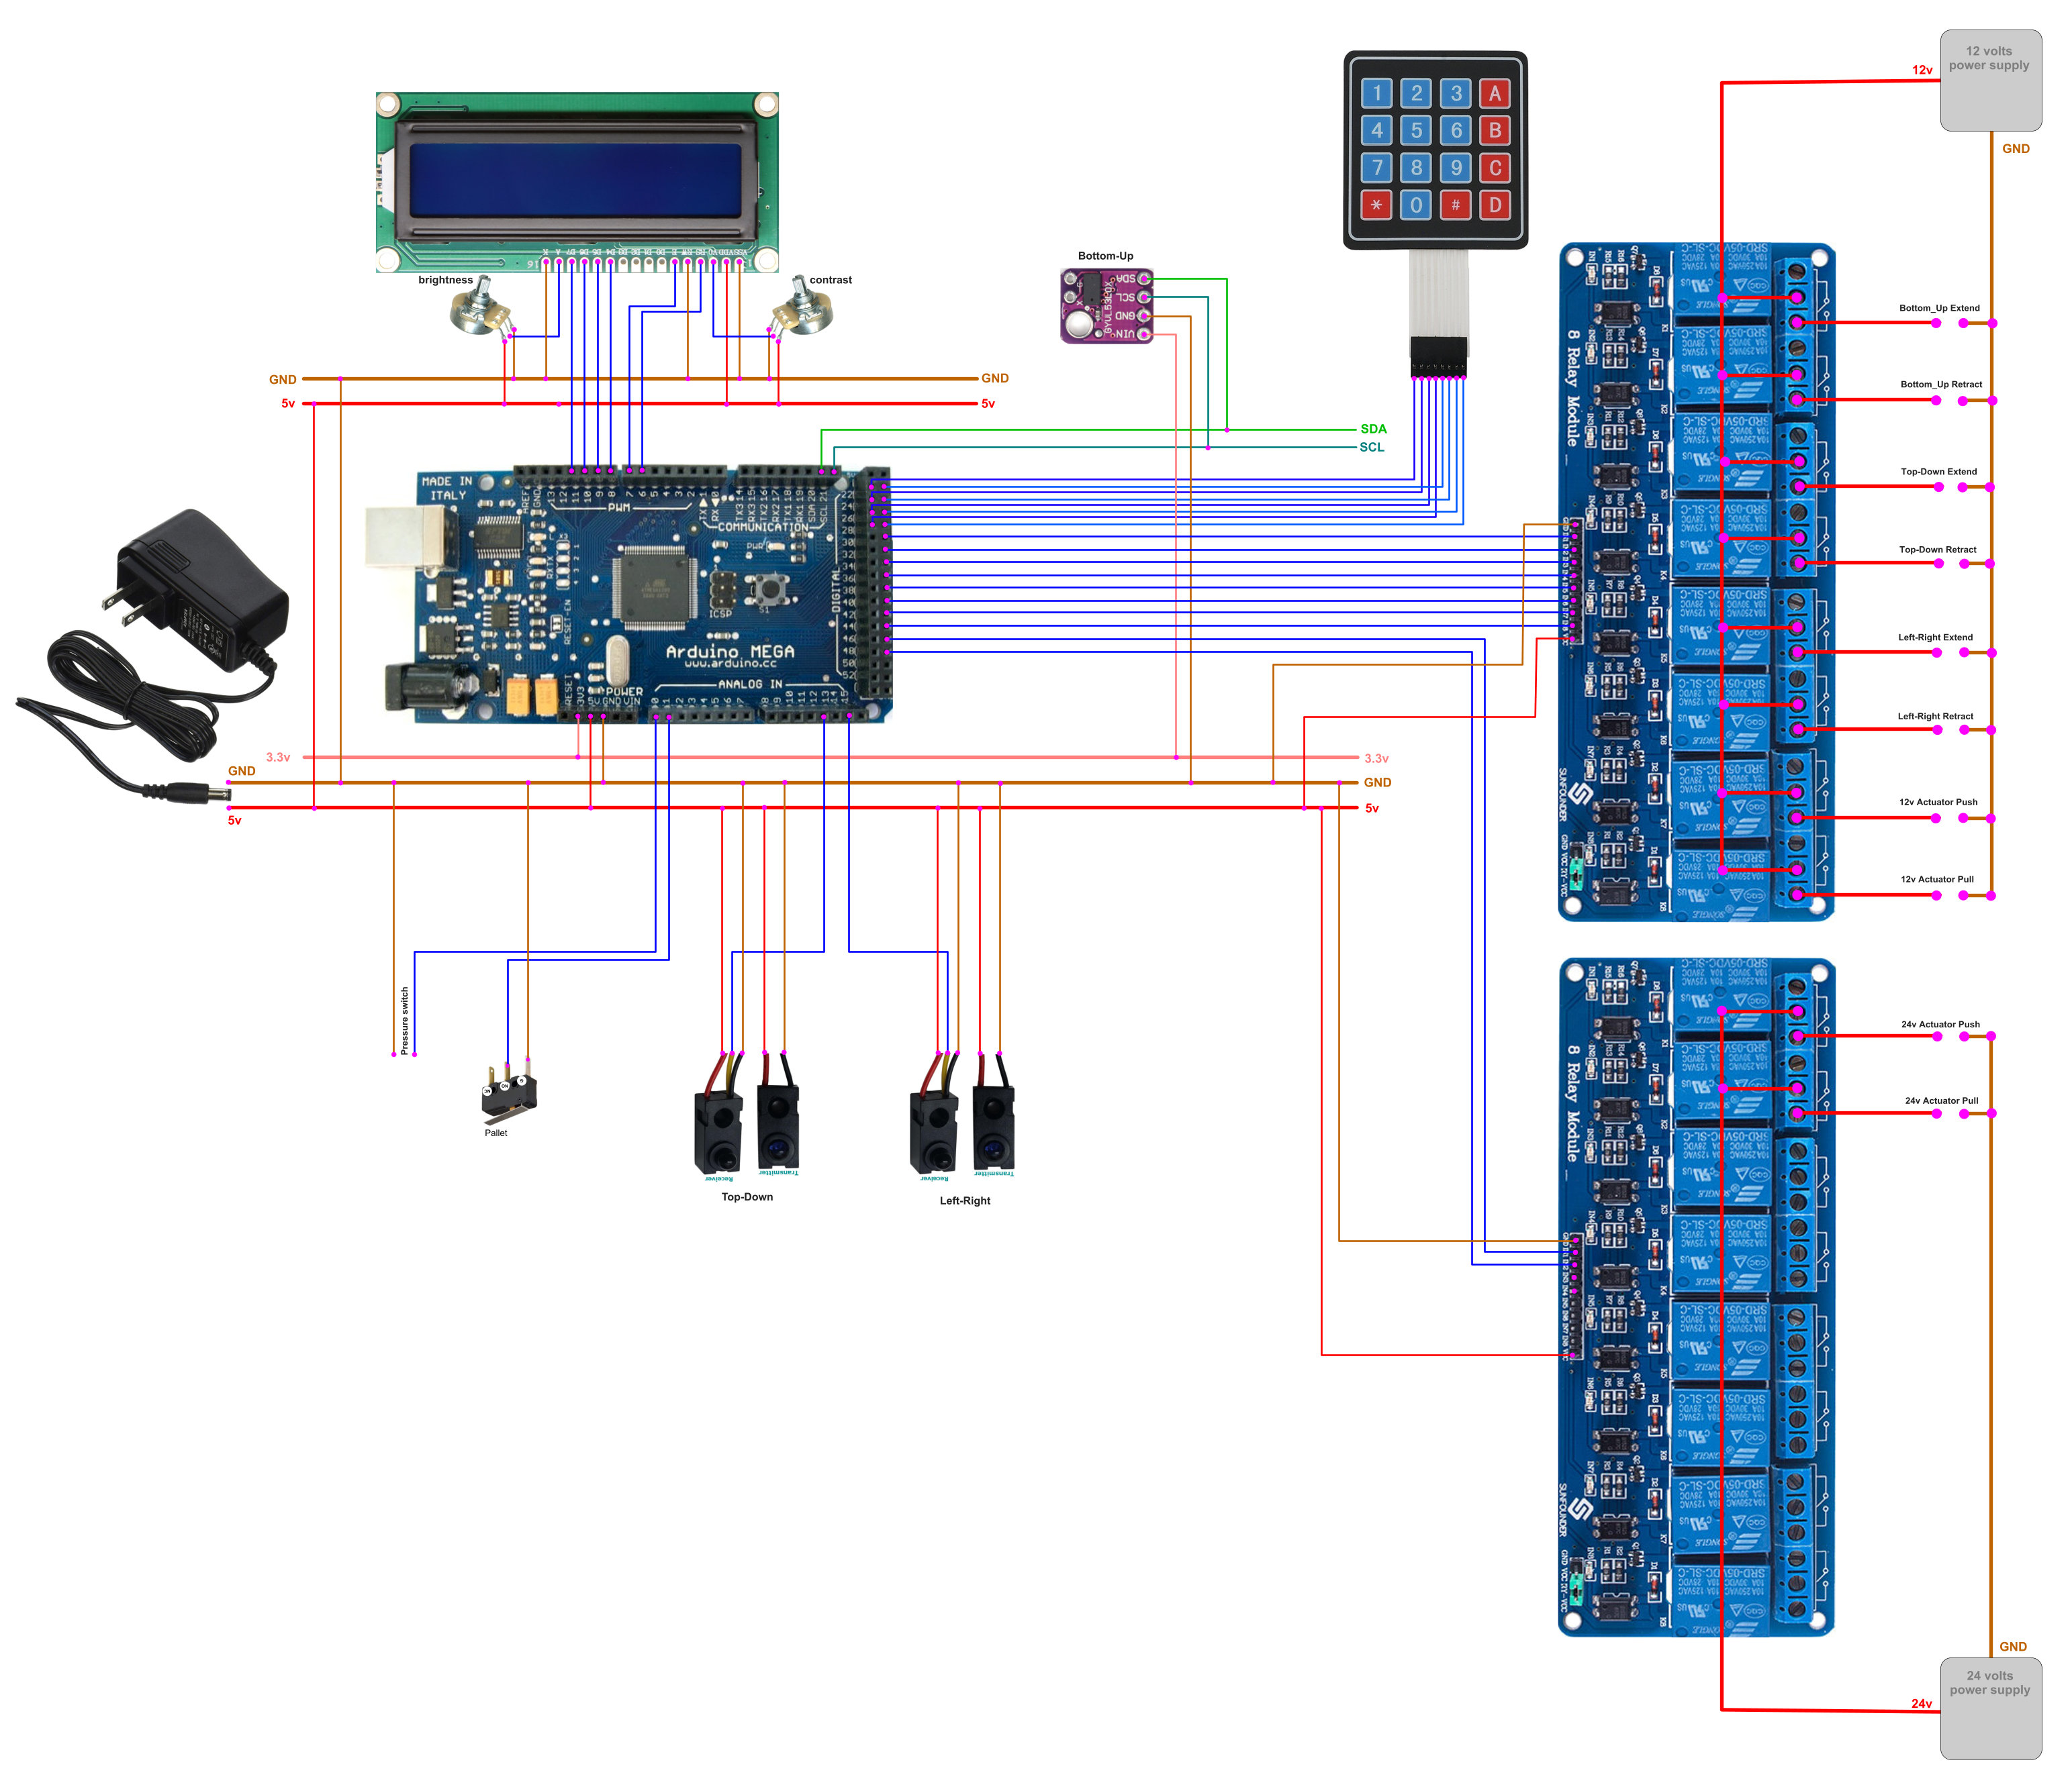

We need to do 3 things:

1. input the desired height of the block (press “D”) to switch to input mode, and then input the desired height in mm (between 50 and 270). Screen shows: “Input block height” and then the numbers as they are pressed. Press “D” again to confirm.
2. Start the automatic sequence (press “*”) screen shows the output as described in the sequence steps below. Sequence will continue until we stop the automatic sequence (press “#”), or until the pallet is full.
3. start an individual part of the automatic sequence. By pressing the corresponding number of the automatic sequence of the keypad once, (1 to 0 for steps 1 to 10, A for step 11, B for step 12) drive the cylinders/actuators until the appropriate sensor tells us to stop that part.

**Display**

I’d like to have the set height of the block permanently displayed on line 1 (we can set a standard height of 240 mm when the software boots up, and change if we need to) then on line 2 the words “automatic sequence” can appear when the automatic sequence is activated. On line 3 whatever is happening (the text that is programmed to appear with each action) and on line 4 the lox distance measurement.

Constant measurements (remain the same always)

bottom up max: 600 mm (cylinder is at maximum extension)

Standard block height: 240 mm (unless we input something different)

Variable TOF measurements

Bottom up start position: = 600 – (“height of block”*1,7)

Bottom up first press position = 600 – (“height of block” *1,2)

Bottom up final press position = 600 – “height of block”

Steps in the automatic sequence

1: Left-right retracts till “midway” position (activate port 6 until IR sensor 2 switches it off) Screen displays “close top”

2: Top Down extends until “close mold” position (activate port 3 until IR sensor 1 switches it off) Screen displays “close mold”

3: Bottom up extends to first press position (activate port 1 until TOF 1 measures “bottom up first press position”) Screen displays “Mid bottom press”

4: Top down extends all the way (activate port 3 until pressure switch switches it off) Screen displays “Max top press”

5: Bottom up extends to final press position (activate port 1 until TOF 1 measures “bottom up final press position”) Screen displays “Max bottom press”

6: retract top down (activate port 4 until pressure switch switches it off) Screen displays “retract top press”

7: retract left-right (activate port 6 until pressure switch switches it off) Screen displays “open top”

8: extend bottom up till max position (activate port 1 until TOF 1 measures “bottom up max”) Screen displays “push out block”

9: extend left-right to midway position (activate port 5 until IR 2 switches it off) Screen displays “push block away”

10: retract bottom up all the way (activate port 2 until pressure switch turns it off). Screen displays “retract bottom press”

11 : Move bottom up to start position (If TOF sensor measures a value greater than “bottom up start position, activate port 1 until TOF measures “bottom up start position”, if it measures a value smaller, activate port 2 until the pressure sensor switches it off, then activate port 1 until TOF measures “bottom up start position”)

Screen displays “bottom start position” and TOF readings

12: Left-right fully extends, (activate port 5 until pressure switch turns it off, wait 2 seconds before starting next step). Screen displays “load sand”

Comment: we need to do both steps 11 and 12, because we need to first retract the Bottom press all the way and then extend it back to the start division. This is to reset the hydraulic flow divider. (the bottom press is 2 hydraulic cylinders that are coordinated with a hydraulic flow divider, but over time some error in this synchronization builds up, so we need to reset it with each pressing).

Running the pallet moving system as part of the automatic sequence

The press will press blocks and push them out of the system on step 12, while it loads the sand) (see video animation <https://www.youtube.com/watch?v=0-BRCh19b1Q>)

These blocks will be pushed on a pallet, and a pallet can hold 2 blocks next to each other. So when 2 blocks are pressed, the pallet has to move over to the left to hold the next row of 2 blocks.

Run the entire automatic sequence twice, then, (while the automatic sequence continues running):

Push pallet away from press 1 cm (activate port 7 for 2 seconds) (12v linear actuator moves 5mm per second)

Push pallet to next loading position (activate port 9 for 3.2 seconds (24v linear actuator moves 20 mm per second)

Retract pallet towards press 1 cm (activate port 8 for 2 seconds)

This sequence should run while the main sequence continues running.

When pallet pushes the micro lever in end position, activate port 10 until pallet pushes micro lever in start position, while finishing the main sequence. When sequence is finished, display “pallet full” on screen, and stop the sequence.

Operator then has to offload the pallet, place a new one, and press the * button to start the new sequence.